Smart Cliff Learning Solutions
KIOT – COE - Expleo – Selenium (Java) -Technical Assessment 17

Module : Web Fundamentals

Date : 07/04/2026
Time : 2.30 pm to 4:30 pm
Duration : 2 Hrs.
Total Marks : 50 Marks

PART A: MCQ (10 x 1 : 10 Marks)
PART B: PRACTICAL QUESTIONS (40 Marks)

B1. HTML – Structure & Forms (CREATE & BUILD) | 10 Marks

Task: Build a Student Registration Webpage
Create a well-structured HTML5 webpage named student_registration.html that meets all the requirements listed below. No inline CSS or JavaScript is required for this task.

Page Requirements:

# | Requirement | Marks
1 | Set the page title in the browser tab to 'Student Registration' | 1
2 | Display a main heading: 'Student Registration Form' at the top of the page | 1
3 | Add a paragraph briefly describing the form's purpose | 1
4 | Create a registration form with: Full Name (text), Email (email type), Date of Birth (date type), Gender (radio buttons: Male / Female / Other)  ,Languages Known(Check Box), Course (dropdown: B.E / M.E / MBA / MCA), and a Submit button | 4
5 | Add an unordered list of at least 3 | 1

# | Requirement | Marks
 | campus facilities below the form
6 | Add a footer with your name and the current year | 2

Note: The Form should be centre aligned horizontally in the page.

<!DOCTYPE html>
<html lang="en">
<head>
<meta charset="UTF-8">
<meta name="viewport" content="width=device-width, initial-scale=1.0">
<title>Student Registration</title>
<link rel="stylesheet" href="style.css">
<script src="validate.js"></script>
</head>
<body>
<center>
<h1>Student Registration Form</h1>
<p>This form is used to register a student with their personal and course details</p>
<form>
<fieldset>
<label>Full Name: </label>
<input type="text" name="fullname" id="fullname" placeholder="Eg: Renu S">
<br><br>

<label>Email: </label>
<input type="email" name="email" id="email" placeholder="Eg: renu@gmail.com">
<br><br>

<label>Date of Birth: </label>
<input type="date" name="dob"id="dob">
<br><br>

<label>Gender: </label>
<div class="gender-group">
<input type="radio" name="gender" value="Male"> Male
<input type="radio" name="gender" value="Female"> Female
<input type="radio" name="gender" value="Other"> Other
</div>
<br><br>

<label>Languages Known: </label>
<div class="language-group">
<input type="checkbox"> Tamil
<input type="checkbox"> English
<input type="checkbox"> Hindi
<input type="checkbox"> Kannada
<input type="checkbox"> Telugu
</div>
<br><br>

<label id="course">Course: </label>
<select>
<option>Choose</option>
<option>B.E</option>
<option>M.E</option>
<option>MBA</option>
<option>MCA</option>
</select>
<br><br>

<input type="submit" value="Submit">
</fieldset>
</form>

<h3>Campus Facilities</h3>
<ul>
<li>Library</li>
<li>Computer Lab</li>
<li>Sports Ground</li>
</ul>

<footer>Rohini M - 2026</footer>

</center>

</body>
</html>

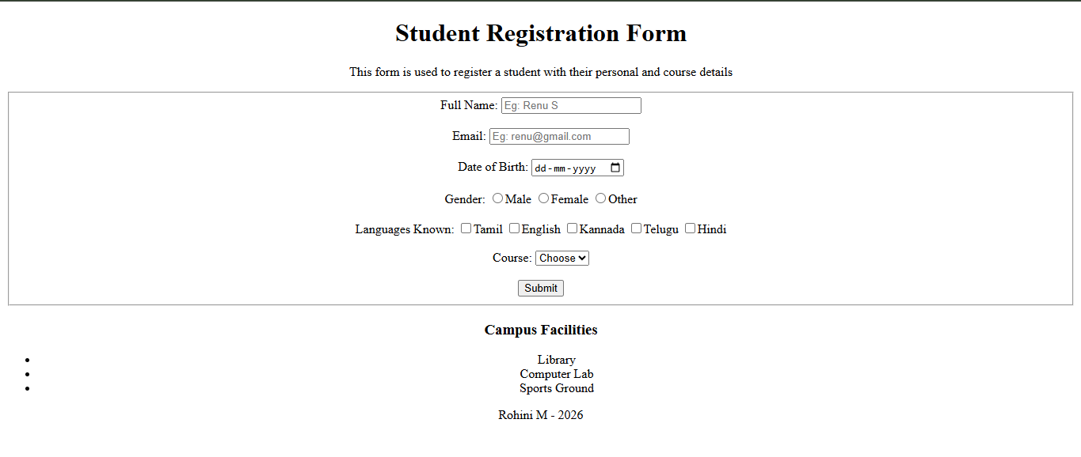

B2. CSS – Styling Tasks | 10 Marks

Link an external stylesheet named style.css to your student_registration.html page created in B1. Write CSS rules to fulfil each requirement below. Attach a browser screenshot showing the styled output.

Q1. Apply the following styles to the <body> element: background colour #f0f4f8, font family Arial, sans-serif, and a margin of 0.

(2 marks)
body{
background-color: #f0f4f8;
font-family: Arial, sans-serif;
margin: 0;
}

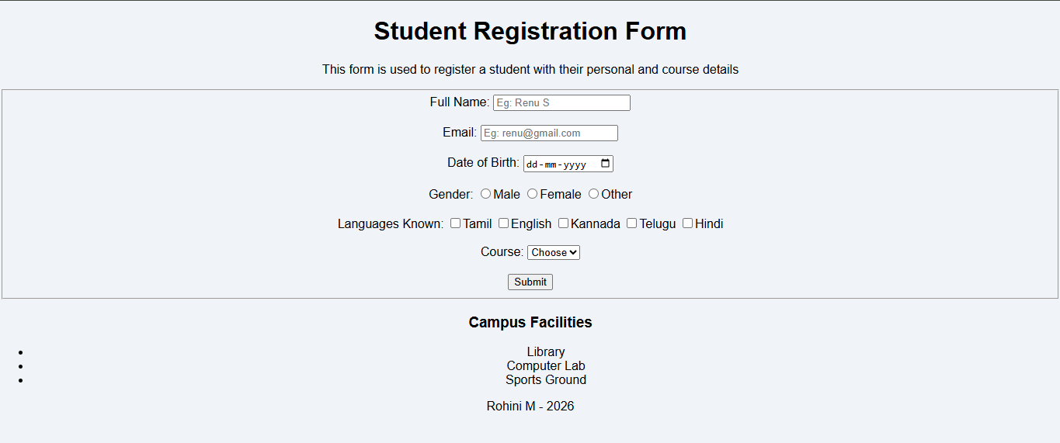
Q2. Style the <h1> heading: text colour #1F3864, centred alignment, font size 2rem, and a bottom border 3px solid #1F3864

(2 marks)
h1{
text-decoration-color: #1F3864;
align-items: center;
font-size: 2rem;
border-bottom: 3px solid #1F3864;
}

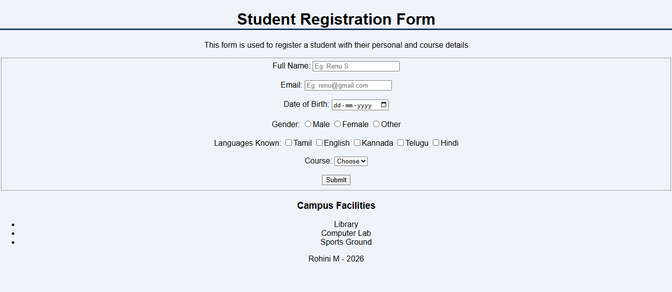

Q3. Style the <form>: display as flex with flex-direction: column, a max-width of 500px, margin: 0 auto, padding 24px, background #ffffff, and a box-shadow: 0 2px 8px rgba(0,0,0,0.1)

(2 marks)
form{
display: flex;
flex-direction: column;
max-width: 500px;
margin: 0 auto;
padding: 24px;
background: #ffffff;
box-shadow: 0 2px 8px rgba(0,0,0,0.1);
}

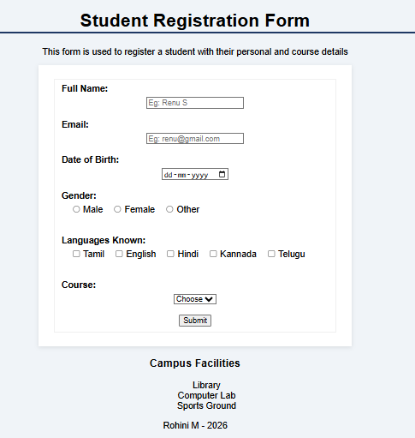

Q4. Style all <input> and <select> elements: width 100%, padding 8px, margin-bottom 12px, border
1px solid #cccccc, and border-radius 4px (2 marks)
input, select{
width: 95%;
padding: 8px;
margin-bottom: 12px;
border: 1px solid #cccccc;
border-radius: 4px;
}
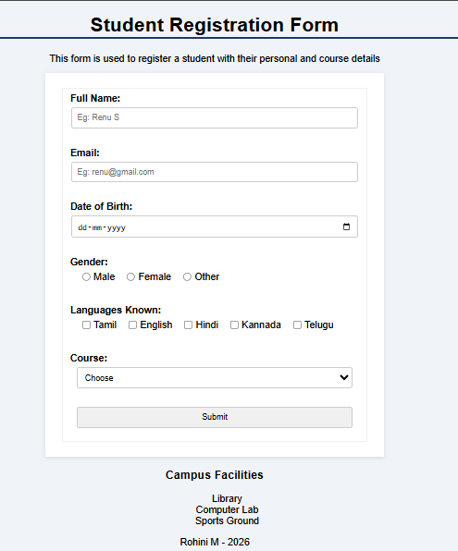

Q5. Write a media query so that when the viewport width is 600px or less, the form's max-width becomes 100% and the body padding becomes 12px

(2 marks)

@media (max-width: 600px) {
form {
max-width: 100%;
}
body {
padding: 12px;
}
}

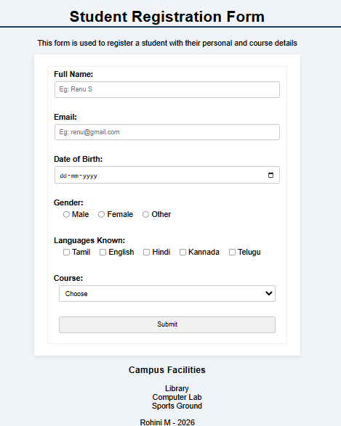
B3. JavaScript – DOM Manipulation & Validation (WRITE & EXECUTE) | 20 Marks


Instructions: Write complete, working JavaScript programs. Attach the .js / .html source file and a browser screenshot showing the output for each task.

B3.1 – DOM Manipulation (10 Marks)
Create a file named todo.html that implements a simple To-Do List application using HTML, CSS, and JavaScript in a single file. The application must:

# | Requirement | Marks
a | Display an <input> text field and an 'Add Task' button on the page. | 1
b | When the button is clicked, read the value from the input field and dynamically create a new <li> element containing the task text, and append it to a <ul> list on the page. | 3
c | Each task item must have a 'Delete' button. Clicking it must remove that specific <li> from the list without affecting other tasks. | 3
d | Prevent adding an empty task – show an alert if the input is blank. | 1
e | Clear the input field automatically after a task is successfully added. | 2

B3.2 – Form Validation (10 Marks)
Link a validate.js file to your student_registration.html from B1. Intercept the form's submit event and validate the following fields using JavaScript before the form is submitted:

# | Field | Validation Rule | Marks
a | Full Name | Must not be empty. Show an error message below the field if blank. | 2
b | Email | Must contain '@' and end with '.com'. Show an error message if invalid. | 3
c | Date of Birth | The student must be at least 17 years old. Calculate age from today's date and show an error if under- age. | 3
d | Course | A course must be selected (not the default placeholder). Show an error if not selected. | 2

Note: All validation errors must appear as styled red text directly below the respective field (not as alert


popups). The form must NOT submit if any validation fails.
<!DOCTYPE html>
<html lang="en">
<head>
<meta charset="UTF-8">
<meta name="viewport" content="width=device-width, initial-scale=1.0">
<title>To-Do Application</title>
</head>
<body>
<div class="container">
<h2>To-Do List</h2>

<input type="text" id="taskInput" placeholder="Enter a task">
<button onclick="addTask()">Add Task</button>

<ul id="taskList"></ul>
</div>
<script>
function addTask() {
let input = document.getElementById("taskInput");
let task = input.value.trim();

if (task === "") {
alert("Please enter a task");
return;
}
let li = document.createElement("li");
li.textContent = task;

}
</script>
</body>
</html>

